Your FTP details are below:

Host name/IP address: 92.205.9.236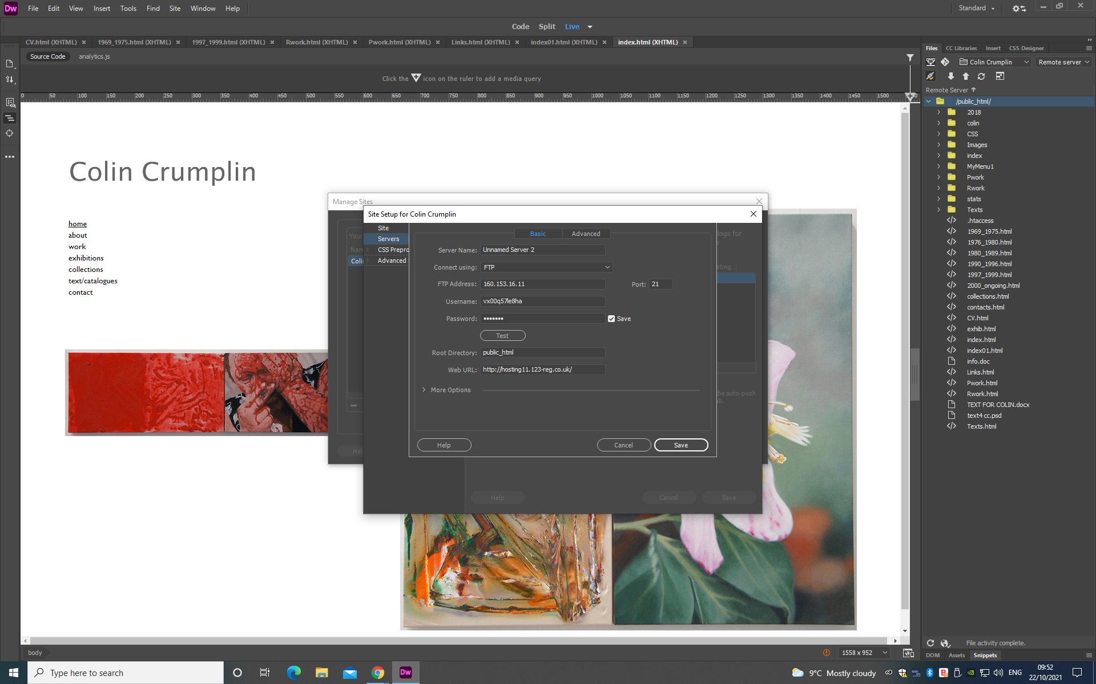
User ID: vx00q57le8ha
Password: Oscar197Maisie610!

Under root folder: set to : public_html

Please remember to name the first page of your website index.html or index.htm (all lower case).

Click top right corner to login
Username: colincrumplin1@gmail.com
Password: Oscar197Maisie610!

